**MASTERMIND PROJECT**

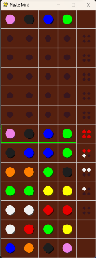**USING (PYGAME)**

RULES:

Rules of the game are quite simple.

* At the beginning of the game decide on how many rounds to be played in order determine a winner.
* Each row needs to be completed before checking, no empty spaces
* Try to guess the code within the given amount of guesses.
* Each colour pin can be used multiple times in a row.
* When code guessed correctly the hidden code will be revealed and you have won the game.

The color-code which needs to be guessed by the codebreaker.

INTRO:

Mastermind is a code breaking game invented in 1970 by Israeli postmaster and telecommunication expert Mordecai Meirowitz. It is an intriguing game played among two players, The code maker and the codebreaker on a MasterMind board which consists of holes and coloured pins to place on them. The columns of the board represent the amount of attempts the codebreaker is allowed to guess the color code correctly and the rows shows the number of pins used for the colour code .The game begins after the code maker places the coloured pins in a particular sequence in a hidden part of the board. The goal of the code breaker is to guess the colour code within the given amount of guesses. For each guess the code maker provides a clue using four pins either red or white placed in a random order, Red pins suggests a correct colour pin placed in the correct position while white pins suggest a correct colour but in the wrong position.

If the code maker manages to guess the colour code correctly he wins and the code maker places red pins for the clue. If not the code maker wins. And the roles are swapped and played again until a winner is determined for a given amount of rounds

.

This is the MasterMind game board. We can see the code of the codemaker at the top and the colour pin selection at the bottom of the board. Positions of the board are indicated by using a square grid. The guesses flow upwards so that the previous tries can be easily referred to.

Selection of 8 colors is given to guess the code. Each colour can be selected by simply left-clicking on the colour.

Hints provided by the code maker to aid the guessing process. 5 attempts are used in the shown picture. Four red colour pins are placed when the colour code is guessed correctly.

OBJECTIVES:

-Creating a working version of MasterMind.

-To understand the pygame capabilities for graphics.

- Improving my programming skills

- Understanding the basics of creating a game.

****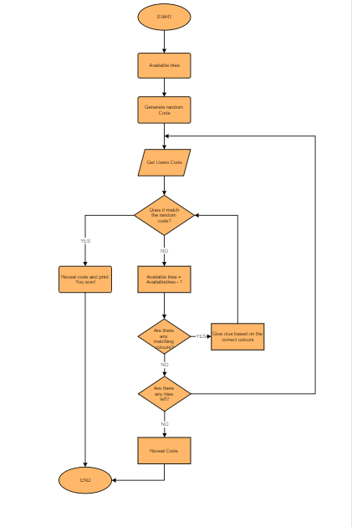

**>Below are the colours used for the whole game. The colours are defined using RGB values and at the end all the colours are assigned to a single variable as colours so that a random colour can be selected easily.**

def events(self):

for event in pygame.event.get():

if event.type == pygame.QUIT:

pygame.quit()

quit(0)

elif event.type == pygame.MOUSEBUTTONDOWN and event.button == 1:

mx, my = event.pos

self.colour = self.board.select_colour(mx, my, self.colour)

print(self.colour)

if self.colour is not None:

self.board.place_pin(mx, my, self.colour)

elif event.type == pygame.KEYDOWN:

if event.key == pygame.K_SPACE or pygame.K_RETURN:

if self.board.check_row():

clues_colour_list = self.board.check_clues()

self.board.set_clues(clues_colour_list)

if self.check_win(clues_colour_list):

print("You Won!!")

self.board.reveal_code()

self.end_screen()

elif not self.board.next_round():

print("Game Over")

self.board.reveal_code()

self.board.next_round()

PURPLE = (238, 130, 230)

BLACK = (30, 30, 30)

ORANGE = (255, 127, 0)

DARKGREY = (35, 42, 45)

LIGHTGREY = (211, 211, 211)

YELLOW = (255, 255, 0)

DARKBROWN = (55, 22, 30)

BLUE = (0, 0, 255)

BGCOLOUR = (85, 32, 15)

GREEN = (0,255,0)

WHITE = (240,240,240)

RED = (230,0,0)

COLOURS = (WHITE,RED,GREEN,YELLOW,BLUE,ORANGE,BLACK,PURPLE)

This is the flowchart which outlines the function of the code for the MasterMind game. This is basically the visual representation of the code.

**This is the code used to create the random colour code for the codebreaker to try and find out.A random sample of 4 colours is selected from COLOURS.And the code is hidden from the codebreaker.**

**SENATH PUSSAWELA / Year12 (ComputerScience)**

[Github Repository](https://github.com/Sena052906/MasterMind.git) [Youtube Gameplay](https://youtu.be/zbZcayZ-xlc?si=OPdB8DKpwBd9q7Ls)

game = Game ()

while True:

game.new()

game.run()

**>This is the main game loop.This creates an instance in the Game class and runs the game in an infinite loop.**

def create_code(self):

random_code = random.sample(COLOURS, 4)

for i, pin in enumerate(self.board_pins[0]):

pin.colour = random_code[i]

pin.revealed = False

**Above is the main function of the game which handles the events. Exiting the game, selecting the colour using mousebutton, and Keydown uses space or enter to lock in the guess and check the result, if guess doesn’t match clue is provided and next round for guess is started.** **Handles various events such as quitting the game, selecting a color, and checking for game over or win conditions**

**This sets up the game board with initializing rows to 5 and columns to 13 and tile size to 60 pixels.Also the frame rate and the title for the game is has also been set here.**

ROWS = 5

COLS = 13

TILESIZE = 60

AMOUNT_COLOUR = 8

WIDTH = (ROWS * TILESIZE) + 1

HEIGHT = (COLS * TILESIZE) + 1

FPS = 60

TITLE = "MasterMind"